|  |
| --- |
| Neighborhood Battle-London  2019 |
|  |
| August 11  Authored by: Sharmila |

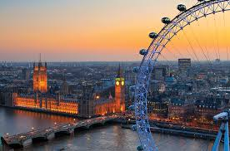

# Table Of Contents

# Title……………………………………………………………………PageNo.

# Introduction…………..……………………………………………………….3

# Data……………………………………………………………………………3

# Introduction

# The intention of this project is to compare London and Birmingham. The analysis would be done based on various list of venues generated by the foursquare API in these neighborhoods to determine which neighborhood is better for livelihood.

# Data Section

# The following data sets, which includes data from Wikipedia and the other open source data in .csv formats would be highly appropriate and helpful in analyzing and visualizing data.

# <https://en.wikipedia.org/wiki/List_of_postcode_areas_in_the_United_Kingdom>

# ukpostcodes.csv

# Postcode_districts.csv

# 